(yeh change kar k humara wala logo or naam ayega)

(yeh hata kar nechay wali dal dena)

Yeh nechy wali hata dena section pura

What to include: (yeh 6 hata do or jo humny by heading dali hai us mei images change kardena)

Carpet Cleaning

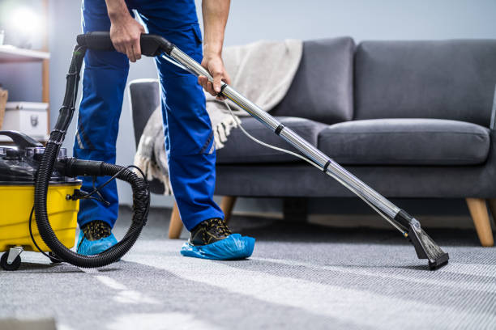

Disinfection Cleaning

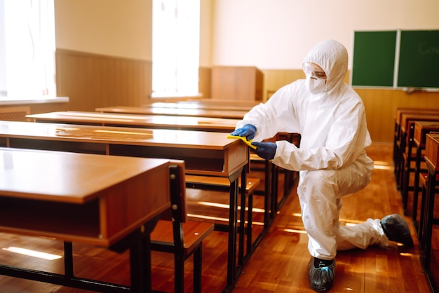

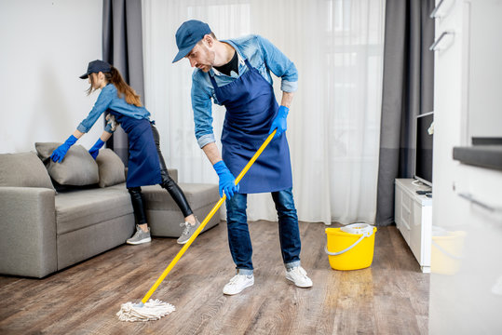Property Cleaning:

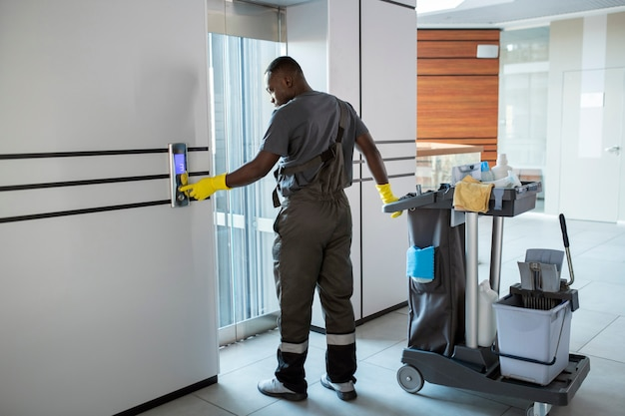Commercial Cleaning:

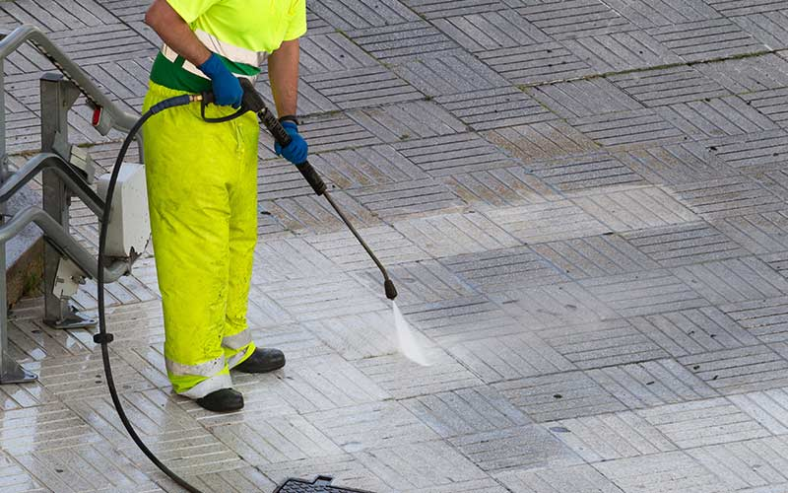Specialist Cleaning:

Connstruction Cleaning:  
Is mei jo already lagi hoi hai usko change karny ki zarurat nahi hai

Phir usky bad:  
is mei sy centre wala part hata do baqi yeh puri picture thek hai

Phir usky bad yeh wala part b theek hai :

Phir is walay part k liye hum sair new pictures send karengy wo dal dena

Phir is part mei apnay map dalna hai jesy unki website mei dala (Pro Active Cleaners) how ahai lekin apnay us per dot wo dalny hai wo is mei cover hongain jesy k

London, Oxfordshire, Cambridgeshire, Bedfordshire, Greater Manchester, Surrey, Buckinghamshire.

Is part mei hum dusri email wali k sath pictures send karengy tow daldena

BAQI YEH SUB SECTIONS THEK HAI :

Yeh WALA part sahe hy add he rhny do is mei or 2 4 dal k yeh sara left to right move hona chahye

Yeh WALA part sahe hy add he rhny do

Yaha pr chat gpt se answer kr do why us wala? Yeh sab thek hai bus chatgpt sy kardo sab k answers, Kahin per bhi **numbers/stats** mentione karny ki zarurat nahi ha .. sirf theory dal do. Picture mei bhi lekh do 100+

Yeh wala part remove he kr do

Proactive k badly humara naam ajaiga

Baqi chezain theek hai

Follow us filala hata dena

Or map bohat achay wala dalna hai apnay or location jo (areas we cover me dali hai usi ko cover kar k dekhani hai )

